RESEAU TP 2

Execrice 1
1) C'est un réseau de Classe A car le premier octet (14) est situé entre 0 et 127.
2) L'adresse de Réseau est 14.230.12.0. L'adresse de Broadcast est 14.230.12.255. Le masque de sous Réseau est 255.255.255.0. On peut connecter au maximum 254 machines.
3)
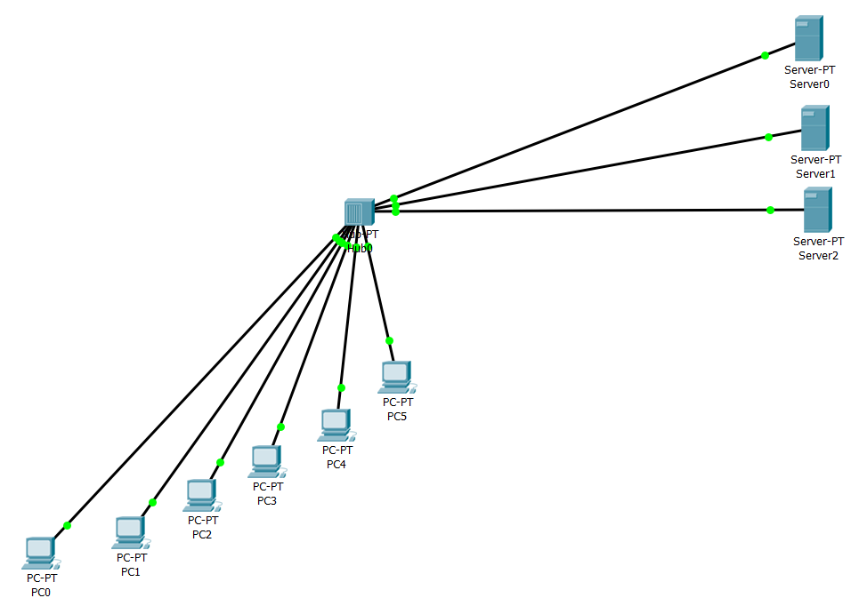

4)
Packet Tracer PC Command Line 1.0
C:\>ping 14.230.12.8
Pinging 14.230.12.8 with 32 bytes of data:
Reply from 14.230.12.8: bytes=32 time=2ms TTL=128
Reply from 14.230.12.8: bytes=32 time=1ms TTL=128
Reply from 14.230.12.8: bytes=32 time<1ms TTL=128
Reply from 14.230.12.8: bytes=32 time=1ms TTL=128
Ping statistics for 14.230.12.8:
Packets: Sent = 4, Received = 4, Lost = 0 (0% loss),
Approximate round trip times in milli-seconds:
Minimum = 0ms, Maximum = 2ms, Average = 1ms

C:\>ping 14.230.12.9
Pinging 14.230.12.9 with 32 bytes of data:
Reply from 14.230.12.9: bytes=32 time<1ms TTL=128
Reply from 14.230.12.9: bytes=32 time<1ms TTL=128
Reply from 14.230.12.9: bytes=32 time<1ms TTL=128
Reply from 14.230.12.9: bytes=32 time<1ms TTL=128
Ping statistics for 14.230.12.9:
Packets: Sent = 4, Received = 4, Lost = 0 (0% loss),
Approximate round trip times in milli-seconds:
Minimum = 0ms, Maximum = 0ms, Average = 0ms

C:\>ping 14.230.12.7
Pinging 14.230.12.7 with 32 bytes of data:
Reply from 14.230.12.7: bytes=32 time=1ms TTL=128
Reply from 14.230.12.7: bytes=32 time=2ms TTL=128
Reply from 14.230.12.7: bytes=32 time<1ms TTL=128
Reply from 14.230.12.7: bytes=32 time<1ms TTL=128
Ping statistics for 14.230.12.7:
Packets: Sent = 4, Received = 4, Lost = 0 (0% loss),
Approximate round trip times in milli-seconds:
Minimum = 0ms, Maximum = 2ms, Average = 0ms

C:\>ping 14.230.12.6

Pinging 14.230.12.6 with 32 bytes of data:
Reply from 14.230.12.6: bytes=32 time<1ms TTL=128
Reply from 14.230.12.6: bytes=32 time=1ms TTL=128
Reply from 14.230.12.6: bytes=32 time<1ms TTL=128
Reply from 14.230.12.6: bytes=32 time<1ms TTL=128
Ping statistics for 14.230.12.6:
Packets: Sent = 4, Received = 4, Lost = 0 (0% loss),
Approximate round trip times in milli-seconds:
Minimum = 0ms, Maximum = 1ms, Average = 0ms

C:\>ping 14.230.12.5
Pinging 14.230.12.5 with 32 bytes of data:
Reply from 14.230.12.5: bytes=32 time=1ms TTL=128
Reply from 14.230.12.5: bytes=32 time=1ms TTL=128
Reply from 14.230.12.5: bytes=32 time<1ms TTL=128
Reply from 14.230.12.5: bytes=32 time<1ms TTL=128

Ping statistics for 14.230.12.5:
Packets: Sent = 4, Received = 4, Lost = 0 (0% loss),
Approximate round trip times in milli-seconds:
Minimum = 0ms, Maximum = 1ms, Average = 0ms

C:\>ping 14.230.12.4
Pinging 14.230.12.4 with 32 bytes of data:
Reply from 14.230.12.4: bytes=32 time<1ms TTL=128
Reply from 14.230.12.4: bytes=32 time=1ms TTL=128
Reply from 14.230.12.4: bytes=32 time<1ms TTL=128
Reply from 14.230.12.4: bytes=32 time<1ms TTL=128
Ping statistics for 14.230.12.4:
Packets: Sent = 4, Received = 4, Lost = 0 (0% loss),
Approximate round trip times in milli-seconds:
Minimum = 0ms, Maximum = 1ms, Average = 0ms

C:\>ping 14.230.12.3
Pinging 14.230.12.3 with 32 bytes of data:
Reply from 14.230.12.3: bytes=32 time<1ms TTL=128
Reply from 14.230.12.3: bytes=32 time<1ms TTL=128
Reply from 14.230.12.3: bytes=32 time<1ms TTL=128
Reply from 14.230.12.3: bytes=32 time=1ms TTL=128
Ping statistics for 14.230.12.3:
Packets: Sent = 4, Received = 4, Lost = 0 (0% loss),
Approximate round trip times in milli-seconds:
Minimum = 0ms, Maximum = 1ms, Average = 0ms

C:\>ping 14.230.12.2
Pinging 14.230.12.2 with 32 bytes of data:
Reply from 14.230.12.2: bytes=32 time=1ms TTL=128
Reply from 14.230.12.2: bytes=32 time<1ms TTL=128
Reply from 14.230.12.2: bytes=32 time=1ms TTL=128
Reply from 14.230.12.2: bytes=32 time<1ms TTL=128
Ping statistics for 14.230.12.2:
Packets: Sent = 4, Received = 4, Lost = 0 (0% loss),
Approximate round trip times in milli-seconds:
Minimum = 0ms, Maximum = 1ms, Average = 0ms

Les machines de chacun de ces trois secteurs se voient puisque nous pouvons, à partir de n'importe laquelle d'entre elles, ping n'importe quelle autre machine sans problème de liaison. Le réseau fonctionne puisque chacune de ces machines appartiennent ont toute la même adresse réseau.

Exercice 2

1) On a un réseau : 14.230.12.0/24 avec le masque 255.255.255.0. On veut diviser ce réseau en trois sous réseaux :
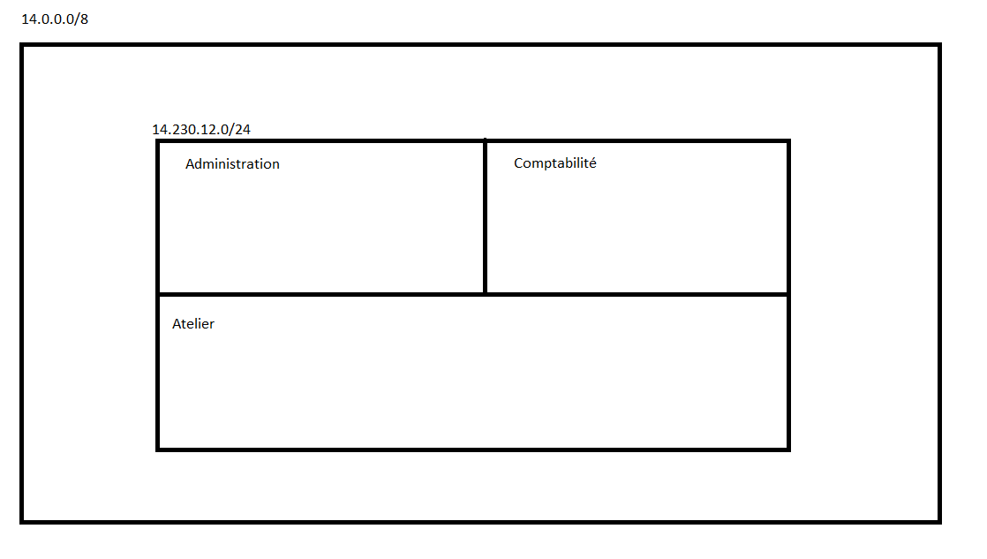
4 = 2² donc il va nous falloir 2 bits pour coder les différents sous réseaux.
On crée donc un nouveau masque : 1111111.111111.1111111.11000000 = 255.255.255.192/26
D’où les adresses des sous réseaux :
14.230.12.0 (00000000 en binaire)
14.230.12.64 (01000000 en binaire)
14.230.12.128 (10000000 en binaire)
14.230.12.192 (11000000 en binaire)
Pour les adresses de broadcast, on va avoir :
14.230.12.63
14.230.12.127
14.230.12.191
14.230.12.255
2)
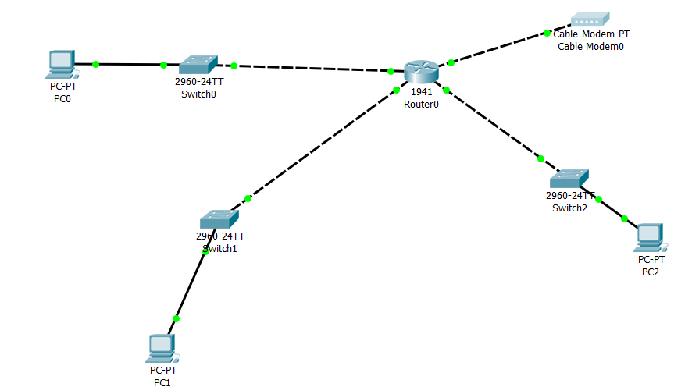
Plan d’adressage :
